**I.B. Tech - I Sem IDEA CREATION-1**

**”Connect Learn Succeed”**

## Department of CSE - (CS)

By

M. KRISHNA CHAITANYA - **2311CS040100**

M.RAGHAVENDRA - **2311CS040112**

M. AKHIL - **2311CS040118**

P.KAVYANJALI **- 2311CS040129**

V.SREEJA - **2311CS040167**

#### Under the Esteemed Guidance of

#### **Mr. K. Vikram (Assistant Professor, CSE)**



## Malla Reddy University

Maisammaguda, Kompally, Hyderabad- 500100, Telangana State. (Telangana State Private Universities Act No. 13 of 2020 & G. O. Ms. No. 14, Higher Education (UE) Department)

##### i



**Department of Cyber Security**

CERTIFICATE

This is to certify that the APP. Development report entitled

“**Connect Learn Succeed**” by M. KRISHNA CHAITANYA (2311CS040100), M. RAGHAVENDRA (2311CS040112), M. AKHIL (2311CS040118), P. KAVYANJALI (2311CS040129), V.SREEJA (2311CS040167) Was submitted in partial fulfillment of the re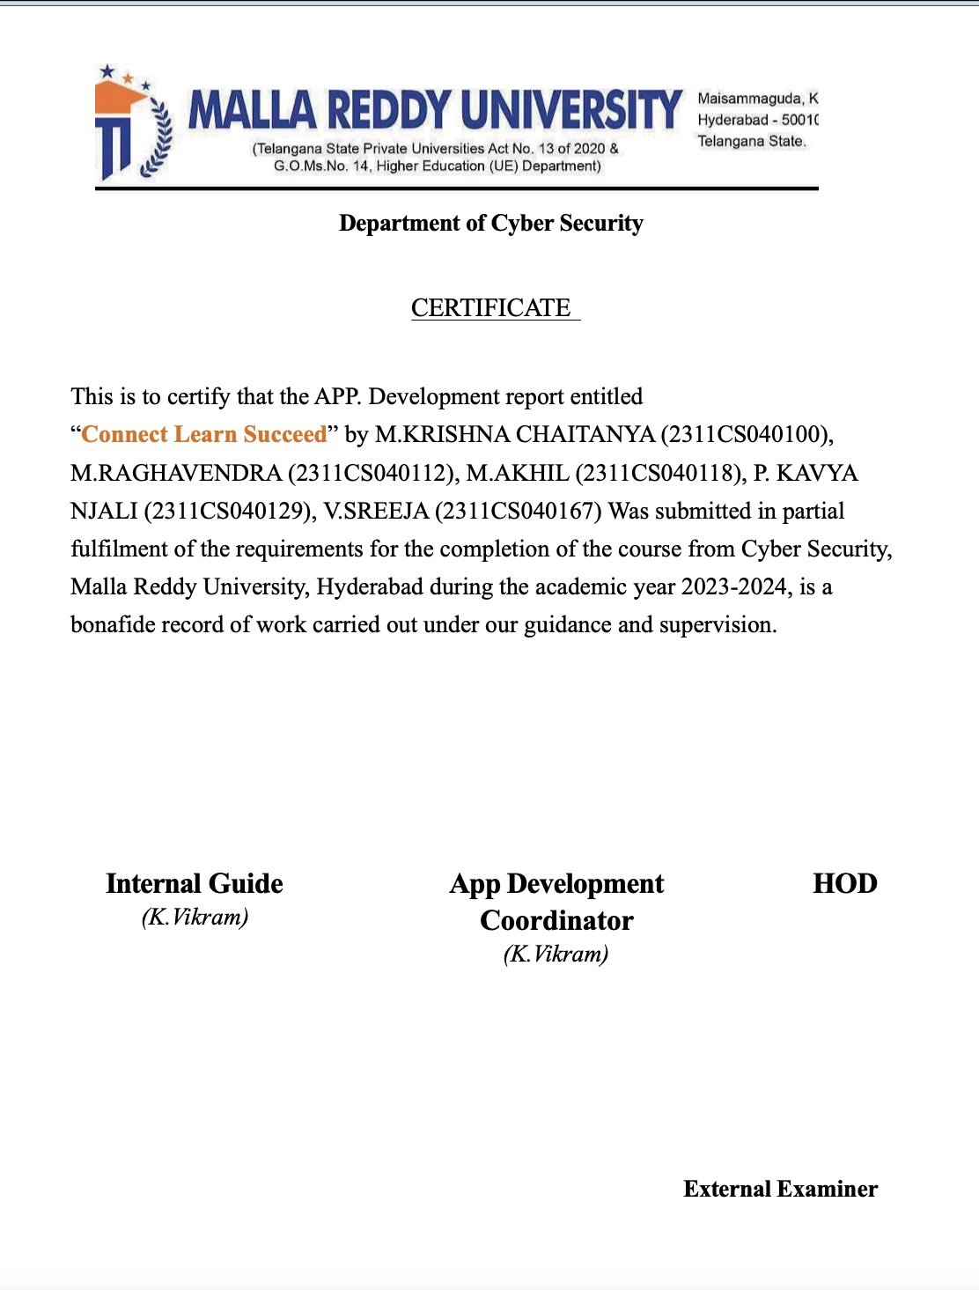quirements for the completion of the course from Cyber Security, Malla Reddy University, Hyderabad during the academic year 2023-2024, is a bonafide record of work carried out under our guidance and supervision.

**Internal Guide**

*(K.Vikram)*

**App Development Coordinator** *(K.Vikram)*

**HOD**

**External Examiner**

**Acknowledgment**

We have been truly blessed to have a wonderful internal guide **Mrs. Shara Lydia**, **Asst. Professor**, Department of CSE, Malla Reddy University for guiding us to explore the ramification of our work and we express our sincere gratitude towards him for leading me through the completion of Project.

We would like to say our sincere thanks to **Mr.K.Vikram**, **Asst.Professor**, Department of CSE, App Development Coordinator, for providing seamless support and right suggestions are given in the development of the APP.

We would like to say our sincere thanks to **Mrs. Lakshmi. T.K, Incharge & Assistant Professor**, Department of CSE I. B.Tech, Mallareddy University for providing seamless support and right suggestions are given in the development of the

APP.

We would like to say our sincere thanks to **T. Sanjeeva Rao.** **Incharge & Assistant Professor**, Department of CSE - (CS) I. B.Tech, Malla Reddy University for providing seamless support and right suggestions are given in the development of the APP.

We wish to express our sincere thanks to **Dr.V.Dhanunjana Chari**, **Dean SOS & I B.Tech SOE**, Mallareddy University for providing us with the conducive environment for carrying through our academic schedules and Project with ease.

We wish to express our sincere thanks to **Vice Chancellor** sir and The Management of Mallareddy University for providing excellent infrastructure and their visionary thoughts to prepare ourselves industry ready by focusing on new technologies.

Finally, we would like to thank our family members and friends for their moral support and encouragement to achieve goals.

M.KRISHNACHAITANYA-2311CS040100

M.RAGHAVENDRA-2311CS040112

M.AKHIL-2311CS040118

P.KAVYANJALI-2311CS040129

V.SREEJA-2311CS040167

# Abstract

Connect learn succeed offers online knowledge that can be delivered for the learner at anywhere,anytime and any age. Connect learn succeed is an integral part of smart education. It is a digital educational environment designed to enhance the educational experience.

Connect learn succeed provides students with access to a wide range of educational resources,including lectures.These platform provide students with the flexibility to access educational materials any resources anytime.These platform has offering accesibility,interactivity and cost-effectiveness

Connect learn succeed development helps students to save hours of time while managing, creating, delivering education and training courses to learners.Due to the negligible training cost, educational institutions who use custom online development software can save 50 to 70% on overall training cost.

Every learners has their own unique needs and preferences. Learners can acquire and retain knowledge at their own pace effectively using custom e-learning development. Connect learn succeed platform is accessible to all the learners from any part of the world and from any device including mobiles, laptops, tablets etc.

This platform has a self registration feature where users can register to any online courses by themselves.This platform helps learners to learn new skills andcoursers with multimedia learning. Connect learn succeed is scalable.you can enroll as many students as you want on your platform.The more learners enroll in the course, the faster you can write off your e-learning app development expense.

# Table of Contents

|  |  |  |
| --- | --- | --- |
| **CHAPTER NO.** | **TITLE** | **PAGE NO.** |
|  | Introduction to APP | 1 |
| 01 | 1.1 Summary of application | 2 |
|  | 1.2 Background of application | 3 |
| 02 | Requirements of application | 4 |
| 03 | Design- algorithm or flow chart  3.1 Screen Shots of APP | 6  8 |
| 04 | Writing your App’s Code | 13  23 |
| 05 | Conclusion | 24 |
| 06 | Future scope | 25 |

**Chapter - 1**

# Introduction To Connect Learn Succeed

Connect learn succeed is a digital environment designed to facilitate and enhance the learning experience for students. connect learn succeed is a new way of acquiring knowledge through technology. It offers a Wide range of educational resources, including video lectures; interactive quizzes.These platforms enable students to access educational content from anywhere,at anytime, making learning more flexible a n d accessible

They have become connect learn succeed provide convenient and effective Way for students to acquire knowledge and skills in various. subjects. This electronic method can be a computer or a smartphone where teaching material is accessed by use of the internet usually. connect Learn succeed can be achieved anywhere. A

student does not need to be physically present in a class. connect Learn succeed can also be termed as a network enabled transfer of skills and Knowledge.

Connect learn succeed is to provide a free, world-class education for anyone, anywhere. The organization achieves this goal by offering a vast library of educational content in various subjects and grade levels. It is built on the belief that education should be accessible to all, regardless of socioeconomic status or geographic location. The platform is committed to providing high-quality, free educational resources to anyone with an internet connection

Connect learn succeed is an online learning platformis a combined set of online services which has ,learners, important resources, tools, and other important educational materials to delivers an extremely powerful and manageable learning environment

it is a secure tool with robust servers and stores learning resources.This integration enables online learning platforms to share data with other products and make courses more accessible.Connect learn succeed is to provide a free, world-class education for anyone, anywhere.

Theorganization achieves this goal by offering a vast library of educational content in various subjects and grade levels. It is built on the belief that education should be accessible to all, regardless of socioeconomic status or geographic location. The platform is committed to providing high-quality, free educational resources to anyone with an internet connection.

* 1. **Summary of Application**

Connect learn succeed platform have revolutionized education by providing students with a flexible and accessible way to acquire knowledge. These platforms offer a diverse range of courses, spanning academic subjects to professional development, accommodating various learning needs.

One of the key advantages of online learning is flexibility. Students can access course materials at any time, allowing them to create personalized study schedules that fit their lifestyles. This flexibility is particularly beneficial for those with work or family commitments, enabling them to pursue education without disrupting their existing responsibilities.

Video lectures deliver course content in a dynamic and engaging format, enhancing comprehension.Another significant aspect is the wide variety of courses available. Students can choose from an extensive range of subjects, from traditional academic disciplines to emerging fields and specialized skills. This diversity empowers learners to tailor their education to their specific interests and career goals, promoting a more personalized and relevant learning journey.

The accessibility of online learning is a key factor in its popularity. Students can access course materials from virtually anywhere with an internet connection, breaking down geographical barriers. This accessibility democratizes education, making it possible for individuals around the world to access high-quality courses and learning resources.

In conclusion, connect learn succeed platform offer students a transformative educational experience characterized by flexibility, diversity of courses. As technology continues to advance, these platforms are likely to play an increasingly crucial role in shaping the future of education, providing accessible and quality learning experiences for students worldwide

Connect Learn Succeed" is an online learning platform designed for students, offering a comprehensive educational experience. The platform facilitates seamless connectivity between students and educators, fostering an interactive learning environment. With diverse course offerings, interactive multimedia resources, and collaborative tools, it empowers students to engage with the material effectively. "Connect Learn Succeed" prioritizes student success by providing personalized learning paths, real-time feedback, and a user-friendly interface. The platform aims to bridge the gap between traditional and online education, offering a dynamic and accessible learning experience for students of various academic levels

# Background of App

The background of an app for students typically involves a response to the evolving needs of the education landscape and the integration of technology to enhance learning experiences. Here's a breakdown of key elements in the background of such apps:

Digital Transformation in Education: The rise of online learning platforms is a response to the digital transformation occurring in education. Recognizing the potential of technology to make education more accessible, these platforms leverage digital tools to deliver courses and educational content.

Increasing Demand for Flexibility: Traditional education models faced challenges in catering to the diverse needs of students, especially those with work or family commitments. Online learning platforms emerged as a solution, offering flexibility in terms of scheduling and accessibility to course materials anytime, anywhere.

Advancements in Technology: The proliferation of high-speed internet and advancements in multimedia technologies paved the way for engaging online content delivery. Video lectures, creating a more dynamic learning experience.

Globalization of Education: Online learning platforms facilitate the globalization of education by connecting learners from different parts of the world. Students can interact with peers, access diverse perspectives, and participate in a global learning community, enriching their educational journey.

Diverse Course Offerings: The background involves a recognition of the need for diverse course offerings. This diversity allows students to pursue their specific interests like html,css,etc and career goals.

Personalized Learning: The background of these apps often includes a shift towards personalized learning experiences. With adaptive learning technologies and customizable study plans, students can progress at their own pace, receiving tailored support to enhance their understanding of the material.

In summary, the background of an online learning platform app for students is rooted in the desire to harness technology for educational advancement, address the changing needs of learners, and provide a flexible, diverse, and globally connected learning environment

# Chapter - 2 Requirements of Application

* **Operating System:** Any operating system compatible with Python.
* **Processor:** Minimum 1 GHz or higher.
* **RAM:** Minimum 2 GB or higher.
* **Storage:** Sufficient disk space to accommodate the application and data.
* **Internet Connection:** Required for location services, database access, and communication features.
* **Python:** Python 3.x installed on the system.
* **Django:**  Django is a high-level web framework for Python that encourages rapid development clean, pragmatic design.
* **Django Installation:**

**>>>**pip install Django

* **Steps to install the module:**
* **Step 1:** Open a command prompt or terminal on your computer.
* **Step 2:** Check if you have Python installed by running the command `python --version` or `python3 --version` (depending on your system). If Python is not installed, download and install the latest version from the official Python website.
* **Step 3:** Install Django using pip, the package installer for Python. Run the command `pip install django` or `pip3 install django` (depending on your system).
* **Step 4:** Wait for the installation process to complete. Pip will automatically download and install the Django module and its dependencies from the Python Package Index (PyPI).
* **Step 5:** After the installation is finished, you can verify if Django was installed correctly. Open a Python interpreter by running the command `python` or `python3` in your command prompt or terminal. Then, type `import django` and press Enter. If there are no errors, Django has been successfully installed.

That's it! You have now installed the Django module on your system

Chapter-3

**Flow Diagram of Login Data**

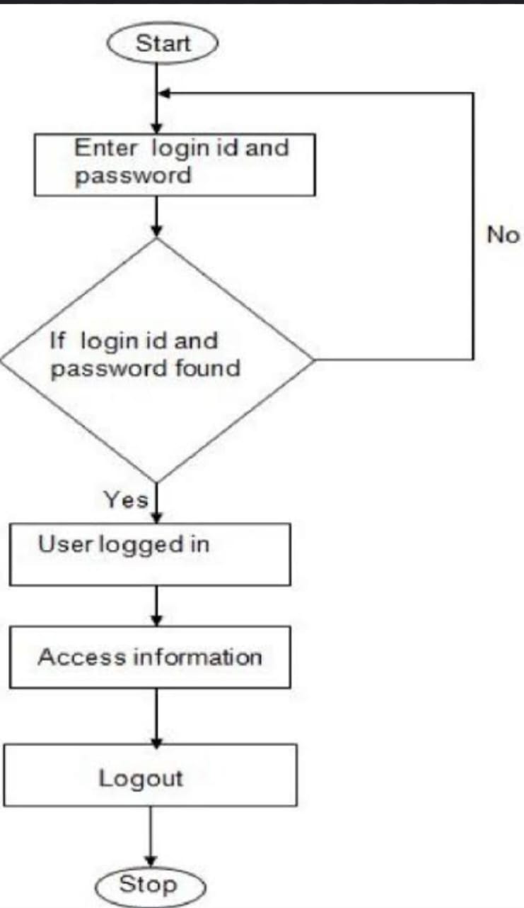

**Fig. 01 Database diagram of App**

# Algorithm

Here's an algorithm for the ThreatHub cybersecurity platform:

1. Start the Connect learn Succeed application.

2. Display the login or registration page.

3. If the user is new, prompt them to register with their desired username, password, and additional security information.

4. If the user is already registered, prompt them to enter their login credentials.

5. Verify the user's credentials against the securely stored database.

6. If the credentials are valid, redirect the user to the dashboard.

7. If the credentials are invalid, display an error message and allow the user to retry or register again.

**Screenshots of Application**

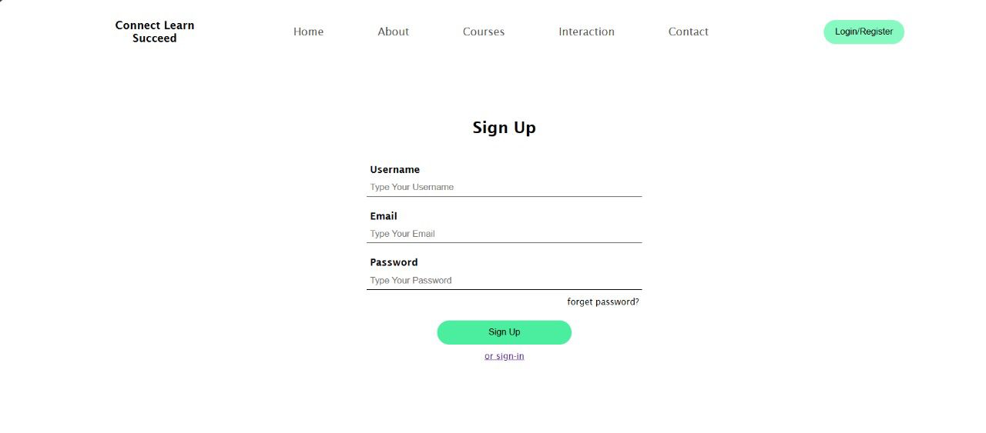

Fig. 1 Sign-Up page

* + 1. The page welcomes users to get Signed up for a new account in Connect Learn Succeed.
    2. Users are asked to register through E-mail for authentication.
    3. Users have to give a Username.
    4. First Name and Last Name for the future reference and Certifications.
    5. They have to select a safe password.

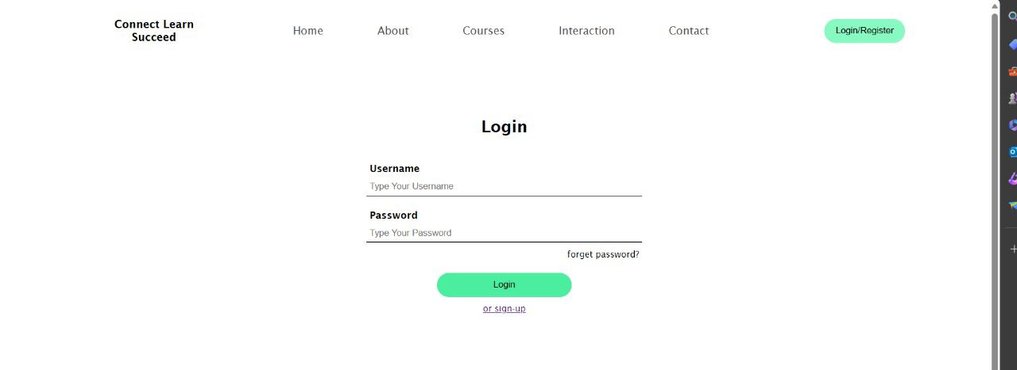

Fig. 2 Login Page

1. Login Page to get an entry into the page once the user registers.
2. Username to gain access.
3. Password to get authentication.
4. If the given credentials are correct, they go to the homepage.
5. If the given credentials are wrong, they get an error message.

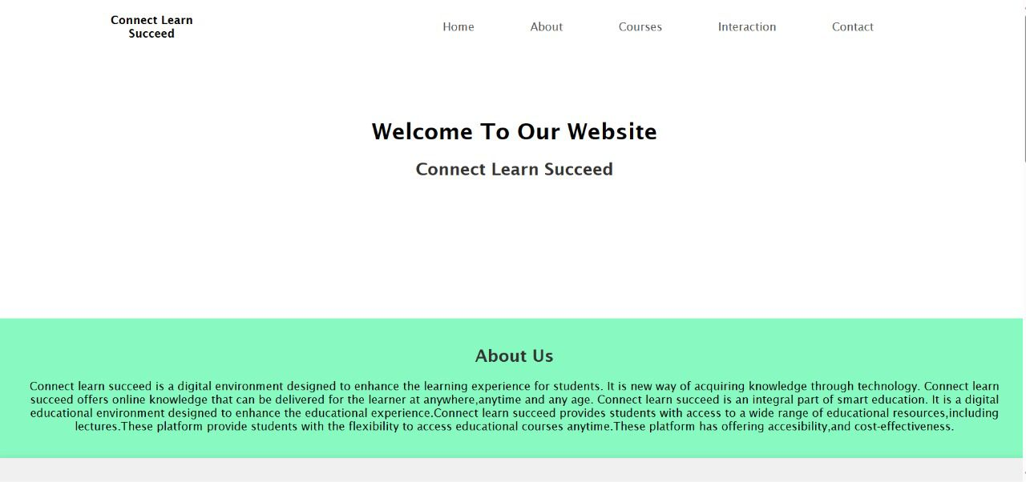

Fig. 3 Home Page

1. Home Page appears as the user enters the website and also whenever someone click Home.
2. As User login to the website, they redirect to homepage with their account.
3. Homepage contains the welcome page of the app
4. Homepage has a slideshow for new updates in the websites.

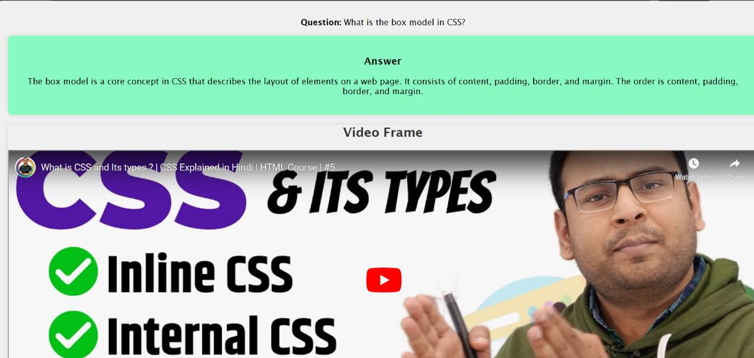

Fig. 4 Question page

**Chapter-4**

**Application Code**

**Views.py**:

from django.shortcuts import render,redirect

from django.contrib.auth.models import User

from django.contrib import messages

from django.contrib.auth import authenticate,login,logout

def home(request):

questions_and_answers = {

'question1': {'question': 'How do you create a hyperlink in HTML?', 'answer': 'Using the <a> (anchor) element. For example:<a href="https://www.example.com">Visit Example.com</a>','n':'1'},

'question2': {'question': 'What is the purpose of the HTML <head> element?', 'answer': 'The <head> element is used to contain meta-information about the HTML document, such as the title, links to stylesheets, scripts, and other metadata.','n':'HcOc7P5BMi4'},

'question3': {'question': 'Explain the difference between <div> and <span> in HTML.', 'answer': ' <div> is a block-level element and is used to group larger sections of HTML content, while <span> is an inline element and is used to group smaller parts of text or other inline elements.','n':'HcOc7P5BMi4'},

'question4': {'question': 'What is the purpose of the HTML attribute "alt" in the <img> element?', 'answer': 'The "alt" attribute provides alternative text for an image. It is displayed if the image cannot be loaded and is also used by screen readers for accessibility. For example:<img src="image.jpg" alt="A descriptive text about the image">','n':'HcOc7P5BMi4'},

'question5': {'question': 'What is JavaScript?', 'answer': 'JavaScript is a high-level, interpreted programming language that is primarily used to add interactivity and dynamic behavior to web pages. It is commonly run in web browsers but can also be executed on server-side platforms.','n':'upDLs1sn7g4'},

'question6': {'question': 'How do you declare a variable in JavaScript?', 'answer': 'You can declare a variable using the var, let, or const keyword. For example: var x = 5; // using var (older way) let y = 10; // using let (block-scoped) const z = 15; // using const (constant)','n':'upDLs1sn7g4'},

'question7': {'question': 'What is the purpose of the if statement in JavaScript?', 'answer': 'The if statement is used for conditional execution. It allows you to execute a block of code if a specified condition is true. For example:if (x > 0) {// Code to be executed if x is greater than 0}','n':'upDLs1sn7g4'},

'question8': {'question': 'What is the box model in CSS?', 'answer': 'The box model is a core concept in CSS that describes the layout of elements on a web page. It consists of content, padding, border, and margin. The order is content, padding, border, and margin.','n':'3lyHNwpfeSE'},

'question9': {'question': 'Explain the difference between margin and padding in CSS.', 'answer': ' Both margin and padding are spacing properties, but they have different purposes. Margin is the space outside the border of an element, creating space between the element and its surrounding elements. Padding is the space between the content of an element and its border.','n':'3lyHNwpfeSE'},

'question10': {'question': 'What does HTML stand for?', 'answer': 'HyperText Markup Language’,'n':'HcOc7P5BMi4'},

}

user_question = request.GET.get('user_question', '')

selected_question = None

for key, qa in questions_and_answers.items():

if qa['question'] == user_question:

selected_question = qa

break

return render(request,"aut/home.html", {'questions_and_answers': questions_and_answers, 'selected_question': selected_question, 'user_question': user_question})

def signup(request):

if request.method == "POST":

username = request.POST["username"]

email = request.POST["email"]

pass1 = request.POST["pass1"]

if User.objects.filter(username=username):

messages.error(request,"Username already exist! try any other Username")

return redirect("signup")

if User.objects.filter(email=email):

messages.error(request,"Email ID already registered!")

return redirect("signup")

if len(username)>10:

messages.error(request,"Username must be under 10 characters")

return redirect("signup")

if len(pass1)<8:

messages.error(request,"Password must be 8 characters or more")

if not username.isalnum():

messages.error(request,"Username must be Alpha-Numeric!!")

return redirect("signup")

myuser= User.objects.create_user(username,email,pass1)

myuser.save()

return render(request,"aut/login.html")

return render(request,"aut/signup.html")

def login_(request):

if request.user.is_authenticated:

return redirect("home")

if request.method == "POST":

username = request.POST["username"]

pass1 = request.POST["pass1"]

user = authenticate(request ,username=username,password=pass1)

if user is not None:

login(request,user)

return redirect("home")

else:

messages.error(request, "Wrong credentials!")

return redirect("login")

return render(request,"aut/login.html")

def logout_view(request):

logout(request)

return redirect("login")

**Code Explanation:**

1 . "home" function:

• Fetches questions and answers from a

dictionary (• questions_and_answers").

• Retrieves the user’s question from the GET

parameters.

• Searches for the user’s question in the

dictionary and assigns the corresponding

answer to selected_question.

• Renders the’aut/home.html'template with

information about questions, selected

question, and user's question. 2 . 'signup" function:

• Handles user registration.

• If the HTTP method is POST, it retrieves username, email, and password from t h e

form.

• Performs various validation checks:

• Checks if the username already exists.

• Checks if the email is already registered. • Ensures the username isa lphanumeric

and under10 characters.

• Requires the password to be atleast 8

Checksiftheemailisalreadyregistered.

• Ensurestheusernameisalphanumeric a n d under 10 characters.

• Requiresthepasswordtobeatleast8 characters.

• Ifallcheckspass,createsanewuserusing

*User.objects.create_user and redirects totheloginpage.

• IftheHTTPmethodisGET,rendersthe 'aut/signup.html' template.

3 . "login_° function:

• Handlesuserlogin.

• Checksiftheuserisalreadyauthenticated;if yes, redirects to the home page.

• IftheHTTPmethodisPOST,retrievesthe usernameandpasswordfromtheform.

• Usesauthenticatetochecktheuser's

credentials.

• Ifauthenticationissuccessful,logsinthe

user and redirects to the home page.

• Ifauthenticationfails,displaysanerror

messageandredirectstotheloginpage.

• If the HTTP metkod is GET, renders the ‘aut/Inainhtml' template

• Checksiftheuserisalreadyauthenticated;i yes, redirects to the home page.

• If the HTTP method is POST, retrieves the usernameandpasswordfromtheform. • Uses'authenticatetochecktheuser's

credentials.

• I f authentication i s successful, logs in t h e

userandredirectstothehomepage. • Ifauthenticationfails,displaysanerror

message and redirects to the login page.

• If the HTTP method is GET, renders t h e 'aut/login.html' template.

4 . logout_view' function:

• Logs out the user using logout and

redirects to the login page.

The code utilizes Django's authentication system,models,and messages to handle user

registration, login, and logout. Additionally, i t demonstrates a simple question-answer retrieval

**Urls.py**:

from django.urls import path

from . import views

urlpatterns=[

path("",views.home,name="home"),

path("login",views.login_,name="login"),

path("signup",views.signup,name="signup"),

path('logout',views.logout_view, name='logout'),

]

**Code Explanation:**

1. `from django.urls import path`: This line imports the `path` function from the `django.urls` module. The `path` function is used to define routes in your Django application.

2. `from . import views`: This line imports the `views` module from the current directory (indicated by the dot `.`). In Django, views are responsible for handling HTTP requests and returning appropriate responses.

3. `urlpatterns`: This is a list that contains instances of the `path` function. Each instance represents a URL pattern and is associated with a specific view.

- `path("", views.home, name="home")`: This line associates the empty path (`""`) with the `home` view function. The `name` parameter is set to "home," which allows you to reference this URL pattern by name in your Django templates or views.

- `path("login", views.login_, name="login")`: This line associates the "/login" path with the `login_` view function. The `name` parameter is set to "login."

- `path("signup", views.signup, name="signup")`: This line associates the "/signup" path with the `signup` view function. The `name` parameter is set to "signup."

- `path('logout', views.logout_view, name='logout')`: This line associates the "/logout" path with the `logout_view` view function. The `name` parameter is set to "logout."

These URL patterns define the routes for your web application. For example:

- Visiting the root URL ("/") will invoke the `home` view.

- Visiting "/login" will invoke the `login_` view.

- Visiting "/signup" will invoke the `signup` view.

- Visiting "/logout" will invoke the `logout_view` view.

**Login page**

<!DOCTYPE html>

<html lang="en">

<head>

<meta charset="UTF-8">

<meta name="viewport" content="width=device-width, initial-scale=1.0">

<title>Document</title>

<style>

/* styles.css */

.main {

width: 100vw;

display: flex;

flex-direction: column;

align-items: center;

position: relative;

min-height: 100vh;

font-family: 'Lucida Sans', 'Lucida Sans Regular', 'Lucida Grande', 'Lucida Sans Unicode', Geneva, Verdana, sans-serif;

}

.wrapper h1 {

font-size: 1rem;

width: 150px;

text-align: center;

}

.navbar-class {

display: flex;

position: absolute;

top: 0;

left: 0;

width: 100vw;

height: 80px;

justify-content: center;

align-items: center;

}

.wrapper {

display: flex;

width: 80vw;

justify-content: space-between;

align-items: center;

}

ul {

display: flex;

}

ul li {

margin-right: 80px;

list-style: none;

cursor: pointer;

color: rgb(82, 82, 82);

}

ul li:hover {

color: black;

}

.navbar-class button {

width: 120px;

padding: 10px;

background-color: #89F9C2;

border: none;

border-radius: 20px;

}

.login-form {

margin-top: 10%;

display: flex;

flex-direction: column;

align-items: center;

}

.field-wrapper {

display: flex;

flex-direction: column;

margin-top: 20px;

}

.field-wrapper label {

font-size: 0.9rem;

font-weight: bold;

margin-left: 5px;

}

.field-wrapper input {

margin-top: 5px;

width: 400px;

padding: 5px;

border: none;

outline: none;

border-bottom: 1px black solid;

}

.forget-field {

margin-top: 10px;

width: 400px;

font-size: 0.8rem;

display: flex;

justify-content: end;

}

.login-form button {

margin-top: 20px;

width: 200px;

padding: 10px;

background-color: #4aee9e;

border: none;

border-radius: 20px;

cursor: pointer;

}

.login-form a {

font-size: 0.8rem;

cursor: pointer;

text-decoration: underline;

margin-top: 10px;

}

</style>

</head>

<body>

<div class="main">

<div class="navbar-class">

<div class="wrapper">

<h1>Connect Learn Succeed</h1>

<ul>

<li>Home</li>

<li>About</li>

<li>Courses</li>

<li>Interaction</li>

<li>Contact</li>

</ul>

<button>Login/Register</button>

</div>

</div>

<form class="login-form" action="/login" method="post">

{% csrf_token %}

<h2>Login</h2>

<div class="field-wrapper">

<label>Username</label>

<input type="text" placeholder="Type Your Username " id="username" name="username" required>

</div>

<div class="field-wrapper">

<label>Password</label>

<input type="password" placeholder="Type Your Password" id="pass1" name="pass1" required>

</div>

<div class="forget-field">forget password?</div>

<button type="submit">Login</button>

<a href="/signup">or sign-up</a>

</form>

</div>

{% if messages %}

<div id="popup" class="popup">

{% for message in messages %}

<p>{{ message }}</p>

{% endfor %}

</div>

{% endif %}

</body>

</html>

d on cybersecurity news.</div>

      </div>

    </div>

  <div class="footer-section">

      <div class="footer-subsection">

        <h4>Explore</h4>

        <ul>

          <li>Articles</li>

          <li>Categories</li>

          <li>Trending</li>

        </ul>

      </div>

      <div class="footer-subsection">

        <h4>Connect</h4>

        <ul>

          <li>Facebook</li>

          <li>Twitter</li>

          <li>Instagram</li>

        </ul>

      </div>

      <div class="footer-subsection">

        <h4>Support</h4>

        <ul>

          <li><a href="/contactus">Contact Us</a></li>

          <li><a href="/faq">FAQ</a></li>

          <li>Help Center</li>

        </ul>

      </div>

      <div class="social-media-logos">

        <img class="social-media-logo" src="{% static 'images/facebook.png' %}" alt="Facebook Logo">

        <img class="social-media-logo" src="{% static 'images/twitter.png' %}" alt="Twitter Logo">

        <img class="social-media-logo" src="{% static 'images/instagram (1).png' %}" alt="Instagram Logo">

      </div>

      <div class="threathub-logo">

        <div>© Threathub.2023</div>

      </div>

    </div>

</body>

</html>

**Code Explanation:**

1. `<!DOCTYPE html>`: Specifies the HTML5 document type.

2. `<html lang="en">`: The opening tag for the HTML document with the language set to English.

3. `<head>`: Contains metadata about the document, including character set, viewport settings, and the document title.

- `<meta charset="UTF-8">`: Specifies the character set as UTF-8.

- `<meta name="viewport" content="width=device-width, initial-scale=1.0">`: Sets the viewport to the width of the device and initial scale to 1 for responsive design.

- `<title>Document</title>`: Sets the document title.

- `<style>`: Contains embedded CSS styles for styling the HTML elements.

### CSS Styles:

The CSS styles define the appearance of various elements on the page, such as the navigation bar, form, and buttons. Here are some key style definitions:

- `.main`: Styles for the main container, including width, flex layout, and font family.

- `.navbar-class`: Styles for the navigation bar, including positioning, width, and height.

- `.wrapper`: Styles for the wrapper within the navigation bar, including flex layout and spacing.

- `ul` and `ul li`: Styles for the unordered list (navigation links) and list items, including spacing and color changes on hover.

- `.login-form`: Styles for the login form, including margin, flex layout, and width.

- `.field-wrapper`: Styles for the input field wrapper, including margin and font styles.

- `.forget-field`: Styles for the "forget password" text.

- `.login-form button`: Styles for the login button.

- `.login-form a`: Styles for the "or sign-up" link.

### HTML Body:

The body of the HTML document contains the content of the web page.

- The main container (`.main`) contains a navigation bar (`navbar-class`) and a login form (`login-form`).

- The navigation bar includes a logo (`h1`), navigation links (`ul li`), and a login/register button (`button`).

- The login form (`form`) includes input fields for the username and password, a "forget password" text, a login button, and a link to the signup page.

### Django Template Tags:

- `{% csrf_token %}`: Django template tag for including a CSRF token in the form.

- `{% if messages %}` and `{% for message in messages %}`: Django template tags for displaying messages (e.g., login success or failure) in a popup.

**Sign up page** **:**

<!-- sign-up page -->

<!DOCTYPE html>

<html lang="en">

<head>

<meta charset="UTF-8">

<meta name="viewport" content="width=device-width, initial-scale=1.0">

<title>Document</title>

<style>

/* styles.css */

.main {

width: 100vw;

display: flex;

flex-direction: column;

align-items: center;

position: relative;

min-height: 100vh;

font-family: 'Lucida Sans', 'Lucida Sans Regular', 'Lucida Grande', 'Lucida Sans Unicode', Geneva, Verdana, sans-serif;

}

.wrapper h1 {

font-size: 1rem;

width: 150px;

text-align: center;

}

.navbar-class {

display: flex;

position: absolute;

top: 0;

left: 0;

width: 100vw;

height: 80px;

justify-content: center;

align-items: center;

}

.wrapper {

display: flex;

width: 80vw;

justify-content: space-between;

align-items: center;

}

ul {

display: flex;

}

ul li {

margin-right: 80px;

list-style: none;

cursor: pointer;

color: rgb(82, 82, 82);

}

ul li:hover {

color: black;

}

.navbar-class button {

width: 120px;

padding: 10px;

background-color: #89F9C2;

border: none;

border-radius: 20px;

}

.login-form {

margin-top: 10%;

display: flex;

flex-direction: column;

align-items: center;

}

.field-wrapper {

display: flex;

flex-direction: column;

margin-top: 20px;

}

.field-wrapper label {

font-size: 0.9rem;

font-weight: bold;

margin-left: 5px;

}

.field-wrapper input {

margin-top: 5px;

width: 400px;

padding: 5px;

border: none;

outline: none;

border-bottom: 1px black solid;

}

.forget-field {

margin-top: 10px;

width: 400px;

font-size: 0.8rem;

display: flex;

justify-content: end;

}

.login-form button {

margin-top: 20px;

width: 200px;

padding: 10px;

background-color: #4aee9e;

border: none;

border-radius: 20px;

cursor: pointer;

}

.login-form a {

font-size: 0.8rem;

cursor: pointer;

text-decoration: underline;

margin-top: 10px;

}

</style>

</head>

<body>

<div class="main">

<div class="navbar-class">

<div class="wrapper">

<h1>Connect Learn Succeed</h1>

<ul>

<li>Home</li>

<li>About</li>

<li>Courses</li>

<li>Interaction</li>

<li>Contact</li>

</ul>

<button>Login/Register</button>

</div>

</div>

<form class="login-form" action="/signup" method="post">

<h2>Sign Up</h2>

{% csrf_token %}

<div class="field-wrapper">

<label>Username</label>

<input type="text" placeholder="Type Your Username" id="username" name="username" required>

</div>

<div class="field-wrapper">

<label>Email</label>

<input type="email" placeholder="Type Your Email" id="email" name="email" required>

</div>

<div class="field-wrapper">

<label>Password</label>

<input type="password" placeholder="Type Your Password" id="pass1" name="pass1" required>

</div>

<div class="forget-field">forget password?</div>

<button type="submit">Sign Up</button>

<a href="/login">or sign-in</a>

</form>

</div>

{% if messages %}

<div id="popup" class="popup">

{% for message in messages %}

<p>{{ message }}</p>

{% endfor %}

</div>

{% endif %}

</body>

</html>

**Code Explanation:**

### HTML Structure:

1. `<!DOCTYPE html>`: Specifies the HTML5 document type.

2. `<html lang="en">`: The opening tag for the HTML document with the language set to English.

3. `<head>`: Contains metadata about the document, including character set, viewport settings, and the document title.

- `<meta charset="UTF-8">`: Specifies the character set as UTF-8.

- `<meta name="viewport" content="width=device-width, initial-scale=1.0">`: Sets the viewport to the width of the device and initial scale to 1 for responsive design.

- `<title>Document</title>`: Sets the document title.

- `<style>`: Contains embedded CSS styles for styling the HTML elements.

### CSS Styles:

The CSS styles are similar to the ones in the login page. They define the appearance of various elements on the page, such as the navigation bar, form, and buttons.

### HTML Body:

The body of the HTML document contains the content of the sign-up page.

- The main container (`.main`) contains a navigation bar (`navbar-class`) and a sign-up form (`login-form`).

- The navigation bar includes a logo (`h1`), navigation links (`ul li`), and a login/register button (`button`).

- The sign-up form (`form`) includes input fields for the username, email, and password, a "forget password" text, a sign-up button, and a link to the login page.

### Django Template Tags:

- `{% csrf_token %}`: Django template tag for including a CSRF token in the form.

- `{% if messages %}` and `{% for message in messages %}`: Django template tags for displaying messages (e.g., sign-up success or failure) in a popup.

### Form Fields:

- The form has an `action` attribute set to "/signup," indicating that the form data will be submitted to the "/signup" URL using the POST method.

- Input fields include username (`username`), email (`email`), and password (`pass1`). Each input field has a corresponding label.

### Links:

- There's a link to the login page with the `href` attribute set to "/login."

**Home page**:

{% load static %}

<!DOCTYPE html>

<html lang="en">

<head>

<meta charset="UTF-8">

<meta name="viewport" content="width=device-width, initial-scale=1.0">

<title>Your Website</title>

<style>

/* Add your CSS styles here */

body {

font-family: 'Lucida Sans', 'Lucida Sans Regular', 'Lucida Grande', 'Lucida Sans Unicode', Geneva, Verdana, sans-serif;

margin: 0;

padding: 0;

}

.main {

width: 100vw;

display: flex;

flex-direction: column;

align-items: center;

position: relative;

min-height: 100vh;

font-family: 'Lucida Sans', 'Lucida Sans Regular', 'Lucida Grande', 'Lucida Sans Unicode', Geneva, Verdana, sans-serif;

}

.wrapper h1 {

font-size: 1rem;

width: 150px;

text-align: center;

}

.navbar-class {

display: flex;

position: absolute;

top: 0;

left: 0;

width: 100vw;

height: 80px;

justify-content: center;

align-items: center;

}

.wrapper {

display: flex;

width: 80vw;

justify-content: space-between;

align-items: center;

}

ul {

display: flex;

}

ul li {

margin-right: 80px;

list-style: none;

cursor: pointer;

color: rgb(82, 82, 82);

}

ul li:hover {

color: black;

}

.navbar-class button {

width: 120px;

padding: 10px;

background-color: #89F9C2;

border: none;

border-radius: 20px;

}

section {

margin-top: 80px;

padding: 20px;

}

footer {

background-color: #333;

color: white;

padding: 10px;

text-align: center;

margin-left: 0%;

width: 100%;

}

.question-box {

background-color: #f0f0f0;

padding: 20px;

border-radius: 8px;

box-shadow: 0 0 10px rgba(0, 0, 0, 0.1);

text-align: center;

}

form {

margin-top: 20px;

}

label {

display: block;

margin-bottom: 8px;

}

input {

width: 80%;

padding: 10px;

margin-bottom: 16px;

box-sizing: border-box;

}

button {

background-color: #89F9C2;

color: white;

padding: 10px;

border-radius: 15px;

color: black;

cursor: pointer;

}

.card-container {

display: flex;

gap: 10px;

/* Adjust as needed */

}

.card {

margin-left: 10px;

flex: 0 0 21%;

/* Adjust as needed */

background-color: #89F9C2;

border-radius: 8px;

box-shadow: 0 0 10px rgba(0, 0, 0, 0.1);

padding: 20px;

margin-bottom: 40px;

}

h2 {

color: #333;

}

p {

color: black;

}

.card p {

color: black;

}

.answer-box {

flex: 0 0 100%;

/* Take full width */

background-color: #89F9C2;

border-radius: 8px;

box-shadow: 0 0 10px rgba(0, 0, 0, 0.1);

padding: 20px;

color: black;

margin-bottom: 20px;

}

.video-frame {

/* Take full width */

border-radius: 8px;

height: 50x;

box-shadow: 0 0 10px rgba(0, 0, 0, 0.1);

margin-bottom: 20px;

}

#about {

text-align: center;

background-color: #89F9C2;

}

.f p {

color: aliceblue;

}

.welcome {

margin-top: 150px;

margin-bottom: 100px;

text-align: center;

}

</style>

</head>

<body>

<div class="main">

<div class="navbar-class">

<div class="wrapper">

<h1>Connect Learn Succeed</h1>

<ul>

<li>Home</li>

<li>About</li>

<li>Courses</li>

<li>Interaction</li>

<li>Contact</li>

</ul>

</div>

</div>

<div class="welcome">

<h1>Welcome To Our Website</h1>

<h2>Connect Learn Succeed</h2>

</div>

<section id="about">

<h2>About Us</h2>

<p>Connect learn succeed is a digital environment designed to enhance the learning experience for students.

It is new way of acquiring knowledge through technology.

Connect learn succeed offers online knowledge that can be delivered for the learner at

anywhere,anytime and any age. Connect learn succeed is an integral part of smart

education. It is a digital educational environment designed to enhance the educational

experience.Connect learn succeed provides students with access to a wide range of

educational resources,including lectures.These platform provide students with the

flexibility to access educational courses anytime.These platform has

offering accesibility,and cost-effectiveness.</p>

</section>

<div class="question-box">

<h2>Ask a Question</h2>

<p>Feel free to submit your question using the form below:</p>

<form method="get" action="{% url 'home' %}">

<label for="user_question">Enter your question:</label>

<input type="text" name="user_question" id="user_question">

<button type="submit">Retrieve Answer</button>

</form>

{% if user_question %}

{% if selected_question %}

<div>

<p><strong>Question:</strong> {{ selected_question.question }}</p>

<div class="answer-box">

<h3>Answer</h3>

<p>{{ selected_question.answer }}</p>

</div>

{% if selected_question.n %}

<div class="video-frame">

<h2>Video Frame</h2>

<!-- Add your video source and controls -->

<iframe width="100%" height="500px" src="https://www.youtube.com/embed/{{ selected_question.n }}"

type="video/mp4">

Your browser does not support the video tag.

</iframe>

</div>

{% endif %}

</div>

{% else %}

<p>No answer found for the entered question.</p>

{% endif %}

{% endif %}

<div class="card-container">

<div class="card">

<img src="{% static 'images/html.png' %}" width="100px" height="100px">

<h2>HTML</h2>

<p>HTML stands for HyperText Markup Language. This is the standard language for building web page.

</p>

</div>

<div class="card">

<img src="{% static 'images/css.svg' %}" width="100px" height="100px">

<h2>CSS</h2>

<p>CSS (Cascading Style Sheets) is used to style and layout web pages </p>

</div>

<div class="card">

<img src="{% static 'images/js.jpeg' %}" width="100px" height="100px">

<h2>JavaScript</h2>

<p>JavaScript is a dynamic programming language that's used for web development, in web

applications, for game development, and lots more.</p>

</div>

<div class="card">

<img src="{% static 'images/python.png' %}" width="100px" height="100px">

<h2>Python</h2>

<p>Python is an interpreted, object-oriented, high-level programming language with dynamic

semantics.</p>

</div>

</div>

<footer class="f">

<p>&copy; 2023 Your Website. All rights reserved.</p>

</footer>

<!-- Add your JavaScript scripts or include external scripts here -->

</body>

</html>

<meta charset="UTF-8">

<meta name="viewport" content="width=device-width, initial-scale=1.0">

<title>Your Website</title>

<style>

/* Add your CSS styles here */

body {

font-family: 'Lucida Sans', 'Lucida Sans Regular', 'Lucida Grande', 'Lucida Sans Unicode', Geneva, Verdana, sans-serif;

margin: 0;

padding: 0;

}

.main {

width: 100vw;

display: flex;

flex-direction: column;

align-items: center;

position: relative;

min-height: 100vh;

font-family: 'Lucida Sans', 'Lucida Sans Regular', 'Lucida Grande', 'Lucida Sans Unicode', Geneva, Verdana, sans-serif;

}

.wrapper h1 {

font-size: 1rem;

width: 150px;

text-align: center;

}

.navbar-class {

display: flex;

position: absolute;

top: 0;

left: 0;

width: 100vw;

height: 80px;

justify-content: center;

align-items: center;

}

.wrapper {

display: flex;

width: 80vw;

justify-content: space-between;

align-items: center;

}

ul {

display: flex;

}

ul li {

margin-right: 80px;

list-style: none;

cursor: pointer;

color: rgb(82, 82, 82);

}

ul li:hover {

color: black;

}

.navbar-class button {

width: 120px;

padding: 10px;

background-color: #89F9C2;

border: none;

border-radius: 20px;

}

section {

margin-top: 80px;

padding: 20px;

}

footer {

background-color: #333;

color: white;

padding: 10px;

text-align: center;

margin-left: 0%;

width: 100%;

}

.question-box {

background-color: #f0f0f0;

padding: 20px;

border-radius: 8px;

box-shadow: 0 0 10px rgba(0, 0, 0, 0.1);

text-align: center;

}

form {

margin-top: 20px;

}

label {

display: block;

margin-bottom: 8px;

}

input {

width: 80%;

padding: 10px;

margin-bottom: 16px;

box-sizing: border-box;

}

button {

background-color: #89F9C2;

color: white;

padding: 10px;

border-radius: 15px;

color: black;

cursor: pointer;

}

.card-container {

display: flex;

gap: 10px;

/* Adjust as needed */

}

.card {

margin-left: 10px;

flex: 0 0 21%;

/* Adjust as needed */

background-color: #89F9C2;

border-radius: 8px;

box-shadow: 0 0 10px rgba(0, 0, 0, 0.1);

padding: 20px;

margin-bottom: 40px;

}

h2 {

color: #333;

}

p {

color: black;

}

.card p {

color: black;

}

.answer-box {

flex: 0 0 100%;

/* Take full width */

background-color: #89F9C2;

border-radius: 8px;

box-shadow: 0 0 10px rgba(0, 0, 0, 0.1);

padding: 20px;

color: black;

margin-bottom: 20px;

}

.video-frame {

/* Take full width */

border-radius: 8px;

height: 50x;

box-shadow: 0 0 10px rgba(0, 0, 0, 0.1);

margin-bottom: 20px;

}

#about {

text-align: center;

background-color: #89F9C2;

}

.f p {

color: aliceblue;

}

.welcome {

margin-top: 150px;

margin-bottom: 100px;

text-align: center;

}

</style>

</head>

<body>

<div class="main">

<div class="navbar-class">

<div class="wrapper">

<h1>Connect Learn Succeed</h1>

<ul>

<li>Home</li>

<li>About</li>

<li>Courses</li>

<li>Interaction</li>

<li>Contact</li>

</ul>

</div>

</div>

<div class="welcome">

<h1>Welcome To Our Website</h1>

<h2>Connect Learn Succeed</h2>

</div>

<section id="about">

<h2>About Us</h2>

<p>Connect learn succeed is a digital environment designed to enhance the learning experience for students.

It is new way of acquiring knowledge through technology.

Connect learn succeed offers online knowledge that can be delivered for the learner at

anywhere,anytime and any age. Connect learn succeed is an integral part of smart

education. It is a digital educational environment designed to enhance the educational

experience.Connect learn succeed provides students with access to a wide range of

educational resources,including lectures.These platform provide students with the

flexibility to access educational courses anytime.These platform has

offering accesibility,and cost-effectiveness.</p>

</section>

<div class="question-box">

<h2>Ask a Question</h2>

<p>Feel free to submit your question using the form below:</p>

<form method="get" action="{% url 'home' %}">

<label for="user_question">Enter your question:</label>

<input type="text" name="user_question" id="user_question">

<button type="submit">Retrieve Answer</button>

</form>

{% if user_question %}

{% if selected_question %}

<div>

<p><strong>Question:</strong> {{ selected_question.question }}</p>

<div class="answer-box">

<h3>Answer</h3>

<p>{{ selected_question.answer }}</p>

</div>

{% if selected_question.n %}

<div class="video-frame">

<h2>Video Frame</h2>

<!-- Add your video source and controls -->

<iframe width="100%" height="500px" src="https://www.youtube.com/embed/{{ selected_question.n }}"

type="video/mp4">

Your browser does not support the video tag.

</iframe>

</div>

{% endif %}

</div>

{% else %}

<p>No answer found for the entered question.</p>

{% endif %}

{% endif %}

<div class="card-container">

<div class="card">

<img src="{% static 'images/html.png' %}" width="100px" height="100px">

<h2>HTML</h2>

<p>HTML stands for HyperText Markup Language. This is the standard language for building web page.

</p>

</div>

<div class="card">

<img src="{% static 'images/css.svg' %}" width="100px" height="100px">

<h2>CSS</h2>

<p>CSS (Cascading Style Sheets) is used to style and layout web pages </p>

</div>

<div class="card">

<img src="{% static 'images/js.jpeg' %}" width="100px" height="100px">

<h2>JavaScript</h2>

<p>JavaScript is a dynamic programming language that's used for web development, in web

applications, for game development, and lots more.</p>

</div>

<div class="card">

<img src="{% static 'images/python.png' %}" width="100px" height="100px">

<h2>Python</h2>

<p>Python is an interpreted, object-oriented, high-level programming language with dynamic

semantics.</p>

</div>

</div>

<footer class="f">

<p>&copy; 2023 Your Website. All rights reserved.</p>

</footer>

**Code Explanation:**

1.1 %loadstatic%}°:Djangotemplatetagto

loadstaticfiles,suchasCSSandimages.

2 . °<IDOCTYPE html>: Declaration of the HTML

versionanddocumenttype.

3 . < h t m l lang="en">: Root HTML element, specifying the language of the document.

4 . •<head>*: Contains metadata about the HTML

document, including character set, viewport

settings, and title.

5 .°<metacharset="UTF-8">*:Specifiesthe

character encoding for t h e document a s UTF-8. 6 . °<meta name="viewport"

content="width=device-width, i n i t i a l - scale=1.0">*:Setstheviewportpropertiesfor

responsive design.

7 . <title>Your Websites/title>:Sets the title oft h eHTMLdocument.

8 . °<style>*: Contains the CSS styles for t h e HTMLdocument.

9 . <body>: Contains the content of the HTML document that will be displayed on the webbage.

9 . <body>: Contains the content of the HTML documentthatwillbedisplayedonthe webpage.

1 0 . < d i v class="main"> :Container for the main contentofthewebpage.

11.< d i vclass="navbar-class">:Containerfor thenavigationbar.

1 2 . < d i v class="wrapper">: Container for elements within the navigation bar, such as logo andmenuitems.

1 3 . •<h1>Connect L e a r n Succeed</h1>*: Heading 1 element with the specified text.

14.<ul>*:Unorderedlistcontainer.

1 5 . <11>°: List item within the unordered list.

1 6 . < d i v class="welcome">: Container for a welcomemessage.

17.‹sectionid="about">:SectionwithanIDfor stylingpurposes.

1 8 . <form method="get" action=" (% u r l "home' %1">*: Form element with the "get"

method and an action attribute pointing to t h e ↓

"home" URL.

19. % 11 user_question %}..-[% endif %3: Django template tag for conditional rendering

based on whether u s e r question' is present.

20.1%i fselected_question%}...{%endif %]°: Django template tag for conditional

renderingbasedonwhether

*selected_question' is present. 21.<divclass="card-container:Container

fora s e tofcards.

2 2 . *<div class="card">:Container for an

individual card with an image, heading, and paragraph.

23.<imgsic="%static"images/html.png'

% ]" wi dt h="100px"h ei ght =" 100px">" Image tagwithasourcefromthestaticfilesand specified dimensions.

24.<footerclass="f">*:Footerelementwitha

class for styling.

**Chapter - 5**

# Conclusion

In conclusion, Connect Learn Succeed appears to be a promising online learning platform for students. Its user-friendly interface, diverse course offerings, and interactive features contribute to a conducive learning environment. However, ongoing updates, user feedback, and adaptability to evolving educational needs will determine its sustained success in the dynamic online learning landscape.

Connect Learn Succeed emerges as a promising online learning platform, fostering a conducive environment for student success. Its user-friendly interface facilitates seamless navigation, while a diverse range of courses caters to varied educational interests. The platform's commitment to interactivity through multimedia elements enhances engagement, making learning a dynamic experience.

Adaptability stands out as a key strength, with regular updates reflecting a dedication to meeting evolving educational needs. The platform's emphasis on building a supportive community through discussion forums and collaborative features fosters a sense of connection among users. The inclusive design ensures accessibility, accommodating diverse learners and contributing to an enriching educational experience.

Connect Learn Succeed, however, faces the ongoing challenge of staying abreast of educational technology trends. Addressing potential gaps in course offerings and refining content based on user feedback will be critical for sustaining its impact. As the platform continues to evolve, maintaining a proactive approach to user needs will be instrumental in solidifying its position as a valuable and enduring resource in the online education landscape

Every learners has their own unique needs and preferences. Learners can acquire and retain knowledge at their own pace effectively using custom e-learning development. Connect learn succeed platform is accessible to all the learners from any part of the world and from any device including mobiles, laptops, tablets etc. This platform has a self registration feature where users can register to any online courses by themselves.

This platform helps learners to learn new skills and coursers with multimedia learning. Connect learn succeed is scalable.you can enroll as many students as you want on your platform.The more learners enroll in the course, the faster you can write off your e-learning app development expense.

# Chapter - 6 Future Scope

The future scope for Connect Learn Succeed appears promising, with several potential avenues for growth and enhancement. Continuous integration of cutting-edge educational technologies, such as augmented reality and artificial intelligence, could elevate the platform's interactive features, providing students with immersive and personalized learning experiences.

Expanding the course catalog to include emerging fields and industries would enable Connect Learn Succeed to stay ahead of evolving educational demands. Collaboration with industry experts and professionals could further enrich the content, ensuring its relevance to real-world applications.

Enhancing adaptive learning algorithms would allow the platform to tailor content to individual learning styles, optimizing the effectiveness of each course. Gamification elements, such as badges and interactive challenges, could be incorporated to enhance engagement and motivation among students.

Moreover, fostering global collaboration by connecting students across geographical boundaries through virtual projects and international partnerships could broaden the platform's impact. Embracing microlearning modules and facilitating continuous skill development would align with the growing trend of lifelong learning in the digital age.

Connect Learn Succeed could also explore opportunities for integration with emerging technologies like blockchain to enhance security, transparency, and credential verification.

In conclusion, the future scope for Connect Learn Succeed lies in embracing technological advancements, expanding content offerings, fostering global collaboration, and adapting to the evolving needs of learners. By staying innovative and responsive, the platform has the potential to become a trailblazer in the ever-expanding landscape of online education

- The page includes placeholder images for topics like HTML, CSS, JavaScript, and Python. These images are loaded from the `static` directory.

- The video frame (`<iframe>`) is conditionally included based on the existence of `selected_question.n`.

- The `footer` contains copyright information.

- JavaScript scripts or external scripts are mentioned but not provided in the code. You can add scripts in the specified section to enhance the interactivity of the website.

This HTML code is part of a Django web application, and it appears to integrate with Django views and models to provide dynamic content such as answering user questions and displaying information about various topics.

border-radius: 4px;

      cursor: pointer;

      transition-duration: 0.4s;

    }

  #signup {

      padding: 8px 16px;

      margin-left: 20px;

      margin-right: 10px;

      background-color: #fdca40;

      color: black;

      border: none;

      border-radius: 4px;

      cursor: pointer;

      transition-duration: 0.4s;

    }

    #login:hover,

    #signup:hover {

      background-color: #fff;

      color: #080708;

    }

    .menu:hover {

      color: #fdca40;

    }

    .sidenav {

      height: 100%;

      width: 0;

      position: fixed;

      z-index: 1;

      top: 0;

      left: 0;

      background-color: black;

      overflow-x: hidden;

      transition: 0.5s;

      padding-top: 60px;

    }

    .sidenav a {

      padding: 8px 8px 8px 32px;

      text-decoration: none;

      font-size: 25px;

      color: white;

      font-family: 'Gill Sans', 'Gill Sans MT', Calibri, 'Trebuchet MS', sans-serif;

      display: block;

      transition: 0.3s;

    }

    .sidenav a:hover {

      color: #fdca40;

    }

    .sidenav .closebtn {

      position: absolute;

      top: 0;

      right: 25px;

      font-size: 36px;

      margin-left: 50px;

    }

    @media screen and (max-height: 450px) {

      .sidenav {

        padding-top: 15px;

      }

      .sidenav a {

        font-size: 18px;

      }

    }

    * {

      box-sizing: border-box

    }

    body {

      font-family: Verdana, sans-serif;

      margin: 0

    }

    .mySlides {

      display: none

    }

    img {

      vertical-align: middle;

    }

    .slideshow-container {

      max-width: 1000px;

      position: relative;

      margin: auto;

      margin-top: 10px;

    }

    .prev,

    .next {

      cursor: pointer;

      position: absolute;

      top: 50%;

      width: auto;

      padding: 16px;

      margin-top: -22px;

      color: white;

      font-weight: bold;

      font-size: 18px;

      transition: 0.6s ease;

      border-radius: 0 3px 3px 0;

      user-select: none;

    }

    .next {

      right: 0;

      border-radius: 3px 0 0 3px;

    }

    .prev:hover,

    .next:hover {

      background-color: rgba(0, 0, 0, 0.8);

    }

    .text {

      color: black;

      background: #fdca20;

      font-family: 'Gill Sans', 'Gill Sans MT', Calibri, 'Trebuchet MS', sans-serif;

      font-size: 18px;

      padding: 10px;

      position: absolute;

      bottom: 0px;

      width: 100%;

      text-align: left;

    }

  .dot {

      cursor: pointer;

      height: 15px;

      width: 15px;

      margin: 0 2px;

      background-color: #fdca40;

      border-radius: 50%;

      display: inline-block;

      transition: background-color 0.6s ease;

    }

    .active,

    .dot:hover {

      background-color: white;

    }

    /* Fading animation */

    .fade {

      animation-name: fade;

      animation-duration: 1.5s;

    }

    @keyframes fade {

      from {

        opacity: .4

      }

      to {

        opacity: 1

      }

    }

    /* On smaller screens, decrease text size */

    @media only screen and (max-width: 300px) {

      .prev,

      .next,

      .text {

        font-size: 11px

      }

    }

    .welcome-container {

      display: flex;

      justify-content: space-between;

      width: 100%;

      height: 200px;

      margin-right: 0%;

      margin-top: 20px;

    }

    .welcome-box {

      background-color: #fff;

      color: #080708;

      font-family: 'Gill Sans', 'Gill Sans MT', Calibri, 'Trebuchet MS', sans-serif;

      font-size: 30px;

      text-align: left;

      padding: 25x;

      flex: 1;

      margin-right: 10px;

    }

    .heading-box {

      background-color: #fff;

      color: #000;

      padding: 0px;

      font-family: 'Silkscreen', sans-serif;

      font-size: 25px;

      text-align: center;

      flex: 1;

      margin-left: 10px;

    }

    .news-section {

      text-align: center;

      margin-bottom: 30px;

      background-color: #080708;

      margin-top: 200px;

    }

    .section-title {

      font-size: 48px;

      font-weight: bold;

      text-align: center;

      margin-bottom: 50px;

      color: #fdca40;

      font-family: 'Times New Roman', Times, serif;

      margin-top: 2px;

    }

    .news-grid {

      display: grid;

      grid-template-columns: repeat(3, 1fr);

      grid-gap: 2px;

      margin-bottom: 10px;

    }

    .news-card {

      background-color: lightyellow;

      padding: 20px;

      border-radius: 8px;

      box-shadow: 0 0 10px rgba(0, 0, 0, 0.1);

      margin-left: 10px;

      margin-right: 10px;

      margin-bottom: 10px;

      cursor: pointer;

    }

    .news-card:hover {

      transform: scale(1.05);

      background-color: #fff;

    }

    .news-card img {

      width: 100%;

      border-radius: 8px;

      margin-bottom: 10px;

    }

    .news-card h3 {

      font-size: 18px;

      margin-bottom: 10px;

      color: #080708;

      text-align: left;

    }

    .news-card p {

      font-size: 14px;

      color: #080708;

      text-align: left;

    }

    .news-card img {

      width: 100%;

      border-radius: 8px;

      margin-bottom: 10px;

    }

    .source-button {

      text-align: center;

      background-color: #080708;

      color: #fdca40;

      padding: 10px;

      border-radius: 6px;

      cursor: pointer;

      transition-duration: 0.4s;

    }

    .source-button:hover {

      background-color: #ccc;

      color: #080708;

    }

    .faq-heading {

      text-align: center;

      color: #fdca40;

      font-size: 20px;

      width: 100%;

      height: 50px;

      margin-top: 5px;

      font-family: 'Silkscreen', sans-serif;

    }

    .faq-section {

      display: flex;

      text-align: center;

      margin-bottom: 30px;

      background: #fff;

      margin-top: 20px;

      margin-left: 0%;

    }

    .faq-box {

      flex: 0 0 32.5%;

      background-color: #fff;

      padding: 25px;

      border-radius: 8px;

      margin-bottom: 20px;

      margin-left: 10px;

    }

    .question-box {

      font-size: 24px;

      font-weight: bold;

      margin-bottom: 10px;

      color: #080708;

      font-family: 'Gill Sans', 'Gill Sans MT', Calibri, 'Trebuchet MS', sans-serif;

    }

    .answer-box {

      font-size: 16px;

      color: #666;

      padding: 20px;

      border-radius: 8px;

      font-family: 'Gill Sans', 'Gill Sans MT', Calibri, 'Trebuchet MS', sans-serif;

    }

    .footer-section {

      display: flex;

      flex-wrap: wrap;

      justify-content: space-between;

      align-items: center;

      background-color: #080708;

      color: #fff;

      padding: 10px 20px;

    }

    .footer-subsection {

      flex: 0 0 30%;

      margin-bottom: 20px;

    }

    .footer-subsection h4 {

      color: #fdca40;

      margin-bottom: 10px;

    }

    .footer-subsection ul {

      list-style: none;

      text-align: justify;

      padding: 20px;

      margin-left: 37%;

    }

    .footer-subsection li {

      margin-bottom: 5px;

    }

    .social-media-logos {

      flex: 0 0 30%;

      display: flex;

      align-items: center;

      margin-left: 45%;

    }

    .social-media-logo {

      margin-top: 50px;

      margin-right: 20px;

      width: 30px;

      height: 30px;

    }

    .threathub-logo {

      flex: 0 0 30%;

      text-align: center;

      margin-left: 35%;

      margin-top: 40px;

      color: #fdca20;

    }

    .signup-box {

      border: 1px solid #ddd;

      background-color: lightyellow;

      color: #080708;

      font-family: 'Gill Sans', 'Gill Sans MT', Calibri, 'Trebuchet MS', sans-serif;

      font-size: 30px;

      padding: 0px;

      border-radius: 8px;

      text-align: center;

      margin-top: 25px;

      /* Add other styles for your signup box */

    }

    .signup-button {

      background-color: #fdca40;

      color: #080708;

      padding: 10px 20px;

      border: none;

      border-radius: 5px;

      font-size: 16px;

      cursor: pointer;

      margin-bottom: 10px;

    }

    .signup-button:hover {

      background-color: #080708;

      color: #fdca40;

    }

    .user {

      margin-top: 250px;

      background-color: #fdca40;

      color: #080708;

      font-size: 35px;

      padding: 0px;

      text-align: center;

      font-family: 'Gill Sans', 'Gill Sans MT', Calibri, 'Trebuchet MS', sans-serif;

      border-color: #ccc;

    }

    .user button {

      background-color: #080708;

      color: #fdca40;

      cursor: pointer;

      margin-right: 15px;

      padding: 8px;

      border-radius: 7px;

    }

    .user p {

    margin-top: 0%;

    }

**Code Explanation:**

This CSS code defines the styling for a web page associated with the ThreatHub cybersecurity platform. Here's a brief summary in five lines:

1. Body Styling:

- Sets the global styling for the page body, including margin, padding, font-family, background color, and text color.

2. Header Styling:

- Defines styling for the header section, including background color, padding, and a flex display for layout.

3. Login and Signup Button Styling:

- Sets styling for login and signup buttons, including padding, background color, margin, border, border-radius, cursor, and transition properties. Also, defines hover effects.

4.Slideshow Styling:

- Specifies styling for a slideshow container, including max-width, position, margin, and positioning of navigation buttons.

5.News Section Styling:

- Defines styling for the news section, including text alignment, background color, and grid layout for news cards. Also includes hover effects for news cards and styling for source buttons.

**Script for Index.html:**

function openNav() {

        document.getElementById("mySidenav").style.width = "250px";

      }

      function closeNav() {

        document.getElementById("mySidenav").style.width = "0";

      }

      let slideIndex = 1;

      showSlides(slideIndex);

      function plusSlides(n) {

        showSlides(slideIndex += n);

      }

      function currentSlide(n) {

        showSlides(slideIndex = n);

      }

      function showSlides(n) {

        let i;

        let slides = document.getElementsByClassName("mySlides");

        let dots = document.getElementsByClassName("dot");

        if (n > slides.length) { slideIndex = 1 }

        if (n < 1) { slideIndex = slides.length }

        for (i = 0; i < slides.length; i++) {

          slides[i].style.display = "none";

        }

        for (i = 0; i < dots.length; i++) {

          dots[i].className = dots[i].className.replace(" active", "");

        }

        slides[slideIndex - 1].style.display = "block";

        dots[slideIndex - 1].className += " active";

      }

      setInterval(function () {

        plusSlides(1);

      }, 8000);

      function login() {

        location.replace("/login")

      }

      function signup() {

        location.replace("/signup")

      }

**Code Explanation:**

This JavaScript code:

1. Defines functions `openNav` and `closeNav` to control the width of a side navigation bar.

2. Manages a slide show using functions `showSlides`, `plusSlides`, and `currentSlide`, along with an automatic slide change every 8 seconds.

3. Contains `login` and `signup` functions, which redirect to "/login" and "/signup" locations, respectively.

4. Uses DOM manipulation to control the visibility of slides and activate corresponding dots in the slideshow.

5. Implements a timed interval using `setInterval` to automatically transition to the next slide in the slideshow every 8 seconds.

**Sign-Up Page Code:**

<!DOCTYPE html>

<html>

<head>

<link rel="preconnect" href="https://fonts.googleapis.com">

<link rel="preconnect" href="https://fonts.gstatic.com" crossorigin>

<link href="https://fonts.googleapis.com/css2?family=Silkscreen&display=swap" rel="stylesheet">

    <style>

body {

    margin: 0;

    padding: 0;

}

header {

    background-color: black;

    color: #fdca40;

    display: flex;

    justify-content: space-between;

    align-items: center;

    padding: 10px;

    font-family: "Silkscreen",sans-serif;

}

.logo {

    font-size: 80px;

    font-weight: bold;

}

.login-button {

    background-color: #fdca40;

    color: black;

    padding: 10px 20px;

    border: none;

    border-radius: 5px;

    cursor: pointer;

    font-family: Arial, sans-serif;

}

.login-button:hover {

    background-color:white;

    color:black;

}

.content {

    display: flex;

    justify-content: space-around;

    margin: 20px;

}

.info-box {

    padding: 20px;

    border-radius: 5px;

    width: 45%;

}

h2 {

    text-align: center;

    color: black;

    font-family: 'Silkscreen',sans-serif;

    font-size: 40px;

}

.info-box h1 {

    font-family: 'Silkscreen',sans-serif;

    text-align: center;

    font-size: 48px;

    color: black;

}

.info-box p {

    font-family:'Gill Sans', 'Gill Sans MT', Calibri, 'Trebuchet MS', sans-serif;

    padding: 30px;

    text-align: center;

    font-size: 30px;

    color: black;

}

.signup-box {

    padding: 20px;

    border-radius: 5px;

    width: 50%;

}

.input-group {

    margin-bottom: 8px;

    text-align: center;

}

label {

    display: block;

}

input {

    width: 50%;

    background-color: whitesmoke;

    padding: 10px;

    margin-top: 10px;

    border: 1px solid #ccc;

    border-radius: 4px;

}

button {

    background-color: black;

    width: 55% ;

    color: #fdca40;

    padding: 10px 20px;

    border: none;

    border-radius: 5px;

    cursor: pointer;

    font-family: Arial, sans-serif;

    font-size: 20px

}

button:hover {

    background-color: #fdca40;

    color:black;

}

body {

    background-color: #ccc;

}

footer {

    background-color: black;

    color: white;

    display: flex;

    justify-content: space-between;

    padding: 10px;

    font-family: Arial, sans-serif;

}

.copyright {

    font-size: 30px;

    padding: 20px;

    font-family:Arial, Helvetica, sans-serif;

    color: #fdca40;

}

.social-media {

    display: flex;

    padding: 20px;

    gap: 30px;

}

.instagram,

.twitter {

    font-weight: bold;

    text-decoration: underline;

    cursor: pointer;

}

.instagram:hover,

.twitter:hover {

    color: #fdca40;

}

p {

    text-align: center;

}

.alert {

    background-color: #ccc;

}

.popup{

    color:red;

    font-family: 'Gill Sans', 'Gill Sans MT', Calibri, 'Trebuchet MS', sans-serif;

    text-align: center;

}

</style>

</head>

<body>

    <header>

        <div class="logo">THREATHUB</div>

    <a href="/login"><div class="login-button" >Login</div></a>

    </header>

    {% if messages %}

    <div id="popup" class="popup">

        {% for message in messages %}

            <p>{{ message }}</p>

        {% endfor %}

    </div>

{% endif %}

    <div class="content">

        <div class="info-box">

            <h1>Welcome to ThreatHub!</h1>

            <p>Uncover the premier center for all cybersecurity news updates. Delve into protected systems, data leak occurrences, and cutting-edge advancements. Stay well-informed and defend your digital assets!</p>

        </div>

        <div class="signup-box">

           <h2>Sign Up</h2>

            <form action="/signup" method="post">

                {% csrf_token %}

                <div class="input-group">

                    <input type="text" placeholder="Username" id="username" name="username" required>

                </div>

                <div class="input-group">

                    <input type="text" placeholder="Firstname" id="fname" name="fname" required>

                </div>

                <div class="input-group">

                    <input type="text" placeholder="Lastname" id="lname" name="lname" required>

                </div>

                <div class="input-group">

                    <input type="email" placeholder="Email ID" id="email" name="email" required>

                </div>

                <div class="input-group">

                    <input type="password" placeholder="Password" id="pass1" name="pass1" required>

                </div>

                <div class="input-group">

                    <input type="password" placeholder="Confirm Password" id="pass2"  name="pass2" required>

                </div>

                <div class="input-group">

                <button  type="submit">Sign Up</button>

            </div>

            <p>Already existing user?<a href="/login">Login</a></p>

            </form>

        </div>

    </div>

    <footer>

        <div class="copyright">© Threathub.2023</div>

        <div class="social-media">

            <div class="instagram" onclick="insta()">Instagram</div>

            <div class="twitter" onclick="twi()">Twitter</div>

        </div>

    </footer>

    <script>

        document.addEventListener('DOMContentLoaded', function () {

        var popup = document.getElementById('popup');

        if (popup) {

            popup.style.display = 'block';

            setTimeout(function () {

                popup.style.display = 'none';

            }, 5000);

        }

    });

        function login() {

  location.replace("C:\\Users\\ataur\\login.html")

        }

        function insta(){

  location.replace("https://www.instagram.com/")

        }

        function twi(){

  location.replace("https://twitter.com/")

        }

    </script>

</body>

</html>

**Code Explanation:**

This HTML file defines the structure and styling for a webpage related to ThreatHub, a cybersecurity platform. Here's a brief overview in five points:

1. Head Section:

- The head section includes links to Google Fonts, specifically the "Silkscreen" font.

- Defines various styles for the body, header, content, info boxes, buttons, forms, and footer using CSS.

- Sets a background color for the body and a black background color for the header and footer.

2. Header Section:

- Contains a header with the ThreatHub logo on the left and a "Login" button on the right.

- The "Login" button is styled with a yellow background color, turning white on hover.

3. Content Section:

- Divided into two main boxes: "info-box" and "signup-box."

- "info-box" provides a welcome message and information about ThreatHub.

- "signup-box" includes a sign-up form with fields for username, first name, last name, email, password, and confirm password.

- The form has appropriate styling with input fields and a sign-up button.

4. Popup for Messages:

- If there are messages (presumably from Django), a popup is displayed at the top of the page.

- Messages are iterated through, and each message is displayed in a paragraph.

5. Footer Section:

- Displays copyright information and social media links (Instagram and Twitter) in a flex layout.

- Social media links are clickable and redirect to Instagram and Twitter.

6. Script Section:

- Uses JavaScript to handle a popup message, which automatically disappears after 5 seconds.

- Provides functions for custom navigation to login page, Instagram, and Twitter.

**Survey and Research**

**Cyber Security, Cyber Threats, Implications and Future Perspectives: A Review**

**Author:** Diptiben Ghelani

Department of Computer Engineering, Gujrat Technological College, Ahmedabad, India

**Abstract:**

There is a wealth of information security guidance available in academic and practitioner literature. Although other tactics such as deterrence, deception, detection, and reaction are possible, most of the research focuses on how to prevent security threats using technological countermeasures. The findings of a qualitative study conducted in Korea to determine how businesses use security techniques to protect their information systems are presented in this article. The results show a deeply ingrained preventative mindset, driven by a desire to ensure the availability of technology and services and a general lack of awareness of enterprise security concerns. While other tactics were evident, they were also preventative measures. The article lays out a research agenda for deploying multiple strategies across an enterprise, focusing on how to combine, balance, and optimize systems. This research looked at various topics, including information security and areas where security strategy is likely to be discussed, such as military sources. There are nine security strategies identified. A qualitative focus group approach is used to determine how these security strategies are used in organizations. In focus groups, security managers from eight organizations were asked to discuss their organizations' security strategies. According to the findings, many organizations use a preventive approach to keep technology services available. Some of the other identified methods were used to support the prevention strategy on an operational level.

**Keywords:** Cyber Security, Cyber Threats, web 3.0, Implications

**To cite this article:**

Diptiben Ghelani.

Cyber Security, Cyber Threats, Implications and Future Perspectives: A Review.

American Journal of Science, Engineering and Technology.

Vol. 3, No. 6, 2022, pp. 12-19

**Received:** May, 09, 2022

**Accepted:** July, 04, 2022

**Published:** August, 05, 2022

**A Cyber Era Approach for Building Awareness in Cyber Security for Educational System in India**

**Author:** Priti Saxena, Bina Kotiyal, R H Goudar

**Abstract:**

Cyber security is the activity of protecting information and information systems (networks, computers, data bases, data centers and applications) with appropriate procedural and technological security measures. Firewalls, antivirus software, and other technological solutions for safeguarding personal data and computer networks are essential but not sufficient to ensure security. As our nation rapidly building its Cyber-Infrastructure, it is equally important that we educate our population to work properly with this infrastructure. Cyber-Ethics, Cyber-Safety, and Cyber-Security issues need to be integrated in the educational process beginning at an early age. The valuable aspects for cyber-security are technology, operations and awareness, training and education. This paper focuses issues related to cyber-security in India and presents various methods in bringing awareness at founder levels in educational system.

**Keywords:** Cyber-infrastructure, social-networking, brain –compatible, cyber–safety, cyber-ethics

**To cite this article:**

Priti Saxena, Bina Kotiyal, R H Goudar

International Journal of Information and Education Technology

Vol. 2, No. 2

**Published:**

April 2012

**A STUDY OF AWARENESS ABOUT CYBERLAWS IN THE INDIAN SOCIETY**

**Author:** Saroj Mehta & Vikram Singh

**ABSTRACT:**

The increased reliance of individuals/organizations on cyberspace has resulted in to a corresponding increase in the cybercrimes. Coupled with lack of proper training and education, the low level of awareness of the Indian society about the cybercrime has resulted into a spurt of cybercrimes. At times, even the law enforcement officers do not have proper training and other requisite expertise for tackling cybercrime. India may succeed in combating the problem of cybercrimes by adopting a synergetic approach wherein technological measures and proper legislative framework with a properly trained human resource in a tech-savvy society.

Although, there exist firewalls, antivirus software, and other technological solutions for safeguarding the data and computer networks, but in India much needs to be done towards effective use of these technologies for safeguarding the precious data and in combating cybercrime. Even most of the seasoned users of IT tools may not be aware of cyber victimization. Along with the advancements in technology it is equally important to be aware of cybercrime and related issues thereof. The cybersafety depends on the knowledge of the technology and the care taken while using internet and that of the preventive measures adopted by user and servers systems. It is well said that the problems created cannot be solved with the same level of awareness that created them. Hence there is need to enhance awareness about the cybercrime.

**To Cite the article:** Saroj Mehta & Vikram Singh

Department of Computer Science

Chaudhary Devi Lal University, Sirsa

**Published:** January 2013

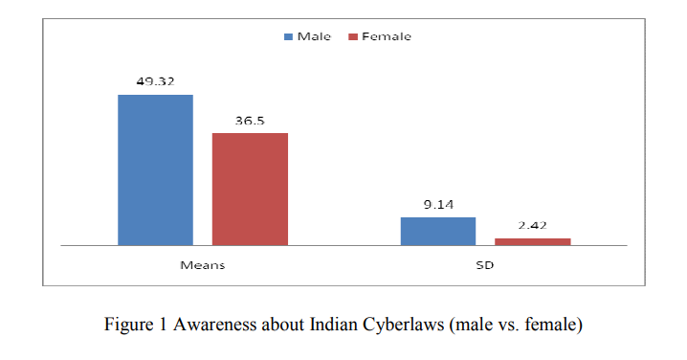

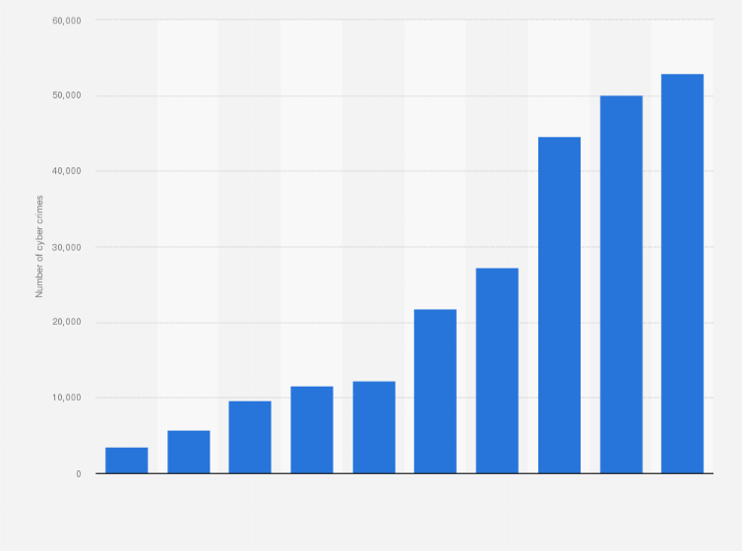

Fig 2 Graph of cyber crime growth

**Chapter - 5**

# Conclusion

In conclusion, ThreatHub stands as a paramount cybersecurity news aggregator, fostering a dynamic and informed community dedicated to staying ahead in the ever-evolving landscape of digital threats. With its sleek design, ThreatHub not only curates the latest and most relevant cybersecurity news but also provides a robust platform for users to fortify their knowledge through LearnHub services and attain valuable certifications.

ThreatHub's commitment to user security is evident not just in its news coverage but also in the stringent measures taken to secure user data during the registration and login processes. The platform ensures a seamless experience, from offering a user-friendly interface to delivering real-time, credible news updates that empower cybersecurity professionals and enthusiasts alike.

The fusion of an intuitive design, up-to-the-minute news coverage, and a comprehensive LearnHub service makes ThreatHub a go-to destination for individuals keen on enhancing their cybersecurity expertise. The platform not only keeps users abreast of the latest threats but also equips them with the tools and knowledge necessary to defend against these challenges. ThreatHub not only addresses the need for information but also facilitates a sense of community, where cybersecurity enthusiasts can connect, share insights, and collectively strengthen the digital defense front.

As we navigate an era marked by increasing cyber threats, ThreatHub stands as a beacon of cybersecurity intelligence, contributing to a safer digital environment by empowering individuals and organizations with the knowledge needed to thwart potential cyber risks. With its emphasis on education, certification, and a vigilant news aggregation system, ThreatHub is undeniably a pivotal player in the realm of cybersecurity, fostering a resilient and well-informed global community.

# Chapter - 6 Future Scope

The ThreatHub cybersecurity news aggregator holds substantial potential for future growth and improvement, aiming to stay at the forefront of the rapidly evolving cybersecurity landscape. Here are some promising future scopes for enhancing ThreatHub:

1. **Expanded Content Diversity:**

- Diversify news sources: Integrate with a broader range of reputable cybersecurity news outlets, blogs, and research institutions to provide users with a more comprehensive and varied perspective on emerging threats and trends.

2. **Real-time Threat Intelligence:**

- Implement real-time threat intelligence feeds: Integrate advanced threat intelligence feeds to deliver up-to-the-minute information on cyber threats, vulnerabilities, and attack vectors, enhancing ThreatHub's value as a real-time cybersecurity resource.

3. **Interactive Learning Hub:**

- Enhance LearnHub services: Expand the LearnHub platform to offer interactive cybersecurity courses, workshops, and virtual labs. Provide hands-on learning experiences and practical exercises to equip users with practical skills and insights.

4. **Collaborative Security Forums:**

- Introduce collaborative forums: Establish discussion forums within ThreatHub to foster a collaborative community. Users can share insights, discuss recent security incidents, and seek advice from experts, promoting knowledge exchange and community building.

5. **Threat Analysis and Reports:**

- Provide in-depth threat analysis: Offer detailed analysis reports on significant cybersecurity incidents, breaches, and attack methodologies. This feature would serve as a valuable resource for security professionals seeking deeper insights into emerging threats.

6. **Customized Threat Alerts:**

- Personalized threat alerts: Allow users to customize threat alerts based on specific keywords, industries, or threat categories. This customization ensures that users receive tailored information relevant to their specific cybersecurity concerns.

7. **Integration with Security Tools:**

- Integrate with cybersecurity tools: Collaborate with leading cybersecurity tools and platforms to provide seamless integration, allowing ThreatHub users to directly access or integrate threat intelligence into their existing security workflows.

8. **User Engagement Metrics:**

- Implement user engagement analytics: Incorporate analytics tools to track user engagement, popular topics, and reading patterns. This data-driven approach can help optimize content delivery, tailor recommendations, and enhance the overall user experience.

9. **Cross-platform Accessibility:**

- Develop mobile applications: Extend ThreatHub's accessibility by developing dedicated mobile applications for both iOS and Android platforms, ensuring users can stay informed about cybersecurity news while on the move.

10. **Global Threat Heatmap:**

- Introduce a global threat heatmap: Visualize real-time cyber threats on a global map, providing users with an intuitive and dynamic overview of the current cybersecurity landscape.

By embracing these future enhancements, ThreatHub can solidify its position as a leading cybersecurity news aggregator, offering a comprehensive suite of services that cater to the diverse needs of cybersecurity professionals, enthusiasts, and organizations globally.

**References**

<https://chat.openai.com/>

<https://claude.ai/>

<https://thehackernews.com/>

<https://www.darkreading.com/>

<https://www.cyberpress.io/>

<https://oktacron.rs/>

<https://sci-hub.com/>

<https://git-hub.com/>

<https://bing.ai>

<https://python.com>

<https://py.pi>

<https://www.django.com>

<https://vscode.com>